Maths  This year we will continue to use the Maths – No Problem! Mastery teaching approach from Singapore. For more information and parent videos, please visit the maths page of our school website: http://www.stjohnfisher-wigston.leics.sch.uk/learning/curriculum/maths  - Place Value: Numbers to 1000  - Addition and Subtraction  - Multiplication and Division  - Measurement: Length |  | English Skills  Reading – focussing on comprehension and understanding.  - Spelling – revisiting high frequency words and using prefixes and suffixes.  - Grammar including articles, singular, plural, adjectives, adverbs, prepositions and verbs.  - Punctuation – including full stops, question marks, exclamation marks and inverted commas  - Handwriting – correct letter formation and correct joins.  Recommended book for Topic:  - Stig of the Dump |  |  | St John Fisher  Voluntary Catholic Academy  Pocket Plans for Parents  Year 3  Galaxy  Group  Advent 2021
RE - Come and see Topics - See separate Parent Letter  - Homes  - Promises  - Visitors  - Other Faith - Judaism |  | PE  First Half Term  - Ball Skills  - Multi-Skills (PE Coach) |  | - PE  - Second Half Term  - Creative game making  - Swimming
French - This term, Year 3 will be learning to:
- Recognise some basic French greetings.
- Recognise the numbers 1-10.
- Respond to some simple classroom instructions.
- Respond to some simple questions when prompted with visual cues.
- Recognise basic family vocabulary.
RSE  Module 1 – Created to Love by God  Unit 1 – Religious understanding  - Session 1 – Get up!  - Session 2 – The Sacraments  Module 2 – Created to Love Others  Unit 1 – Religious understanding  - Story Sessions – Jesus, My Friend. | 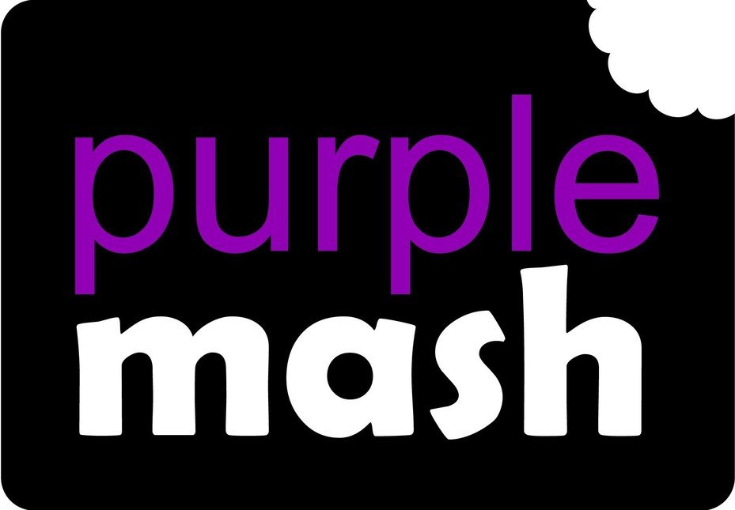  Computing  - Coding  - Online Safety  - Spreadsheets  In under 2 minutes, discover how to use the Parent Portal which gives you clear insight into your child's learning activities in Computing by clicking here. |  | Science Animals including humans  This unit teaches the importance of the right type and amount of nutrition as well as the functions of skeletons and muscles.  Forces and Magnets  This unit teaches about forces, friction and magnetic attraction.

