Working with Parents

Children’s learning begins at birth and develops rapidly. As parents you are the greatest influence on your children and are the first and most enduring educators. When parents and school staff work together it has a positive impact on the child’s development and learning, throughout their school life.

A successful partnership needs a two-way flow of information, knowledge and expertise. We will keep you informed through informal chats, a home-school link book, a reading record book and parent’s evenings in the autumn and spring term, when targets for next steps will be given, and a report in the summer term.

Each child also has a ‘Learning Journey, which is built up over the year to show examples of learning for your child and comments about learning and well-being from the child, teacher and parent. We encourage you to share with us any significant information about your child, (WOW moment) which will then be added to their “Learning Journey.” This could range from learning to ride a bicycle without stabilisers, to a certificate for swimming, dancing or some other talent.

It may be necessary for you to share with us some private or personal information, which could affect your child’s learning such as a family problem or bereavement. This would be treated strictly in confidence and not added to their Learning Journey.

We encourage you to come into school and share experiences with your children. Every Tuesday morning from the beginning of the day until 9.45am, you are invited to share a range of classroom activities with your child. It is also an opportunity to speak with Reception class staff and become familiar with your children’s friends. During this time we would like you to share your child’s “Learning Journey” with them and add your own valued observations into their book.

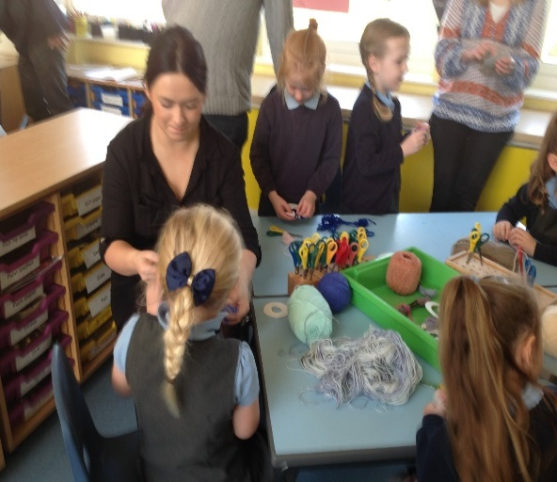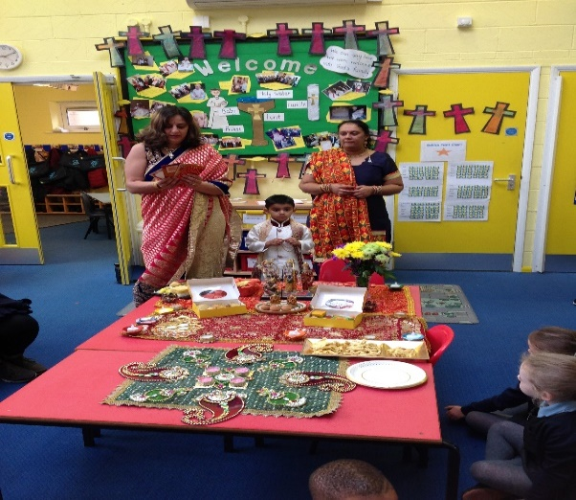

School masses, a class assembly and a class liturgy have always been well attended.
Next year we intend to continue this practice and hope you will be able to join us.

Finally, enjoy your child’s time at school. It is precious. Our aim is to work together for the good of the children so that they can reach their full potential.

