What do good readers do? Help your child to learn the skills to become a good reader.
Predict  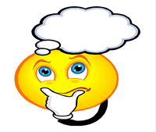  I will think what the chapter is about.  I will think what happens next.  I can:  - Use the title  - Use the headings  - Use the illustrations  - Use what I have already read  - The last chapter….  - In the last paragraph… but  - In the next paragraph..  - The heading tells me…  I will read the text to check my predictions  I can change my predictions as the author gives me more information | Clarify  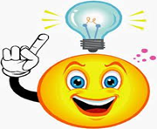  I will write down the words and phrases I do not understand  I will find out what they mean  I can:  - Stop and think what the author wants me to know  - Re-read or read to find clues  - Picture it in my mind  - Think about what I already know  - Make sure I am using the punctuation  - Read faster or slower  - Look for the base word  - Try another word that makes sense  - Use a dictionary | Question  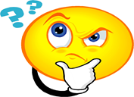  I will ask questions to help me understand what I have read  I will think of questions while I am reading the text  - What? When?  - Who? Why?  - Why is …important  - Why did….do that?  - What are the differences between?  - What would you do?  - What do you think about?  - What are the reasons for?  - Is…fact or fiction? How do you know?  - How do you feel about the character?  - What part was most interesting? Why?  - How is the author making us feel excited? Scared? | Summarise  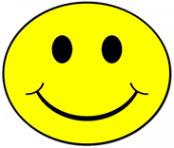  I will identify the main idea in the text.  I will say what the page is about in two sentences.  I will leave out the small details.  I will use headings, titles, and the topic sentence.  I can say things like…  - This page is about…  - The main point of this paragraph is…  - The main idea is….  - The next idea is …..  - The most important information is ….  - In this part of the story….  - The author is telling me…  - The author wants me to think….

