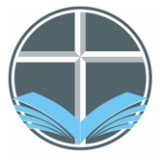
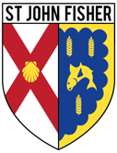
Come and See Curriculum Map
Overview of the RE Curriculum 2021-2022

Advent  2021 | Domestic Church (Family)  4 weeks  25th Aug – 24th Sept 2021  Early Years - Myself - God knows and loves each one  Year 1 - Families - God’s love and care for every family  Year 2 - Beginnings - God is present in every beginning  Year 3 - Homes - God’s vision for every family  Year 4 - People - The family of God in Scripture  Year 5 - Ourselves - Created in the image and likeness of God  Year 6 - Loving - God who never stops loving | Judaism  2 weeks  27th Sept – 8th Oct 2021  Early Years - Hanukkah  Year 1 - Abraham and Moses  Year 2 - Shabbat  Year 3 - Synagogue  Year 4 - Torah  Year 5 - Passover  Year 6 - Rosh Hashanah, Yom Kippur | Baptism/Confirmation (Belonging)  4 weeks  11th Oct – 12th Nov 2021  Early Years - welcome - Baptism: a welcome to God’s family  Year 1 - belonging - Baptism: an invitation to belong to God’s family  Year 2 - signs and symbols - Signs and symbols in Baptism  Year 3 - promises - Promises made at Baptism  Year 4 - called - Confirmation: a call to witness  Year 5 - LIFE CHOICES - Marriage, commitment and service  Year 6 - vocation and commitment - The vocation | Advent/Christmas (Loving)  5 weeks (Assessment Task)  15th Nov – 21st Dec 2021  Advent begins on 28th November  Early Years - birthday - Looking forward to Jesus’ birthday  Year 1 - waiting - Advent: a time to look forward to Christmas  Year 2 - preparations - Advent: preparing to celebrate Christmas  Year 3 - visitors - waiting for the coming of Jesus  Year 4 - gift - God’s gift of love and friendship in Jesus  Year 5 - hope - Advent: waiting in the joyful hope for Jesus, the promised one  Year 6 - expectations - Jesus born to show God to the world

Come and See Curriculum Map
Overview of the RE Curriculum 2021-2022

Lent  2022 | Local Church (Community)  5 weeks (Assessment Task)  5th Jan – 4th Feb 2022  Early Years - CELEbrating - People celebrate in Church  Year 1 - special people - People in the parish family  Year 2 - Books - The books used in Church  Year 3 - Journeys - Christian family’s journey with Christ  Year 4 - Community - Life in the local Christian community and ministries in the parish  Year 5 - mission - Continuing Jesus’ mission in diocese (ecumenism)  Year 6 - sources - the Bible, the special book for the Church | Eucharist (Relating)  4 weeks  7th Feb – 11th March 2022  (Half term within this)  Lent begins on Ash Wednesday 2nd March  Early Years - gathering - Parish family gathers to celebrate Eucharist  Year 1 - meals - Mass, Jesus’ special meal  Year 2 - thanksgiving - Mass, a special time to thank God  Year 3 - listening & Sharing - Jesus gives himself to us  Year 4 - giving & receiving - Living in communion  Year 5 - memorial Sacrifice - Eucharist as the living memorial of Christ’s sacrifice  Year 6 - unity - Eucharist enabling people to live in communion | Lent/Easter (Giving)  4 weeks  14th March – 8th April 2022  Holy Week 10th April  Early Year - growing - Looking forward to Easter  Year 1 - change - Lent: a time for change  Year 2 - opportunities - Lent: an opportunity to start anew  Year 3 - giving all - Lent: remembering Jesus’ total giving  Year 4 - self discipline - Celebrating growth to new life  Year 5 - sacrifice - Lent: a time of aligning with the sacrifice made by Jesus  Year 6 - death & new life - Celebrating Jesus’ death and resurrection

Come and See Curriculum Map
Overview of the RE Curriculum 2021-2022

Pentecost  2022 | Pentecost (Serving)  3 weeks  25th April – 13th May 2022  Ascension - 26th May  Early Years - GOOD NEWS - Passing on the Good News of Jesus  Year 1 - Holidays and Holydays - Pentecost: feast of the Holy Spirit  Year 2 - spread the word - Pentecost: a time to spread the Good News  Year 3 - ENERGY - Gifts of the Holy Spirit  Year 4 - NEW LIFE - To hear and live the Easter message  Year 5 - TRANSFORMATION - Celebration of the Spirit’s transforming power  Year 6 - WITNESSES - The Holy Spirit enables people to become witnesses. | Reconciliation (Inter-relating)  3 weeks (Assessment Task)  16th May – 10th June 2022  Early Years - FRIENDS - Friends of Jesus  Year 1 - BEING SORRY - God helps us choose well  Year 2 - RULES - Reasons for rules in the Christian family  Year 3 - CHOICES - Importance of examination of conscience  Year 4 - BUILDING BRIDGES - Admitting wrong, being reconciled with God and each other  Year 5 - FREEDOM & RESPONSIBILITY Commandments enable Christians to be free & responsible  Year 6 - HEALING - Sacrament of the Sick | Islam  1 week  13th June 2022  Early Years – Prayer mats  Year 1 – Muhammad  Year 2 – Prayer at home  Year 3 – The mosque  Year 4 – The Qur’an  Year 5 – Ramadan and Pilgrimage  Year 6 – Guidance for Muslims | Universal Church (World)  3 weeks  20th June –7th July 2022  Pentecost – 5th June 2022  Early Years - OUR WORLD - God’s wonderful world  Year 1 - NEIGHBOURS - Neighbours share God’s world  Year 2 - TREASURES - God’s treasure; the world  Year 3 - SPECIAL PLACES - Holy places for Jesus and the Christian community  Year 4 - GOD’S PEOPLE - Different saints show people what God is like  Year 5 - STEWARDSHIP - The Church is called to the stewardship of Creation  Year 6 - COMMON GOOD - Work of the worldwide Christian family

Overview for Judaism – Advent Term 2021
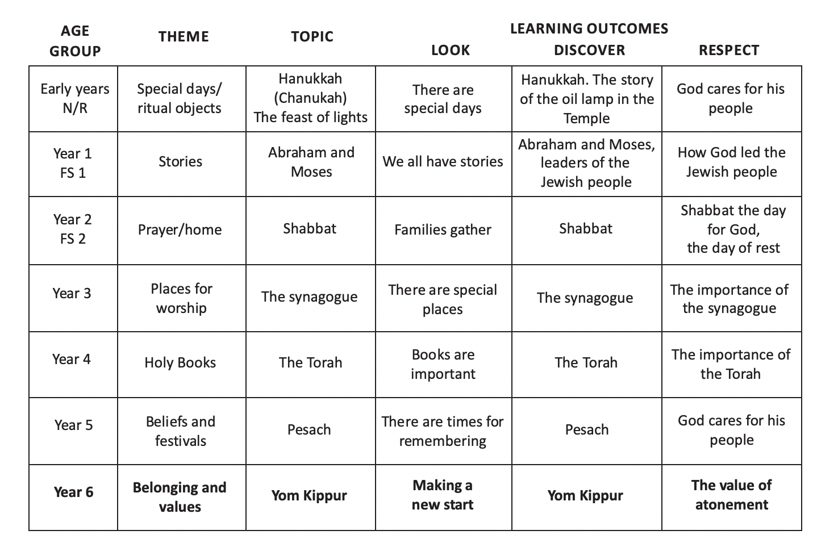

Overview for Islam - Pentecost Term 2022
