Home Learning Resources
A selection of website links to cross-curricular videos and resources to support home learning. All of these resources are currently free and do not rely on printer access. Many of these websites are producing daily content during the period of school closures.
(Right click on each resource title to open hyperlinks)

Resource | Description | Curriculum Area | Age Range
The National Literacy Trust- Family Zone  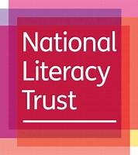 | A web portal for parents, to support you during this time.  Split up by age group, you will find regularly updated ideas and guidance for simple activities that will engage your children at home, while also benefiting their reading, writing and language development.  You'll be able to access free reading and writing resources, audiobooks, videos, competitions and reading challenges. | English | EYFS/KS1/KS2
Oxford Owl  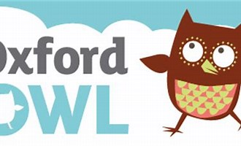 | OxfordOwl online gives access to lots of reading scheme books. You can set it for the computer to read it to them or so the children read - either way, it is great especially if you are unsure what books are suitable for your children. | English | EYFS/KS1/KS2
PhonicsPlay  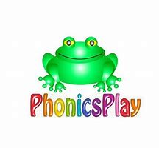 | A site packed with interactive phonics games and resources | English/Phonics | EYFS/KS1
Scholastic Learn at Home  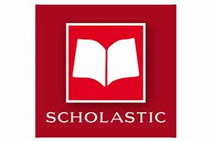 | You can keep the learning going with these special cross-curricular journeys. Every day includes four separate learning experiences, each built around a thrilling, meaningful story or video. | English/Cross-curricular | EYFS/KS1/KS2
Sing with Grammarsaurus  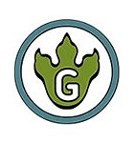 | A great and engaging way to teach children grammar through song. | English/Grammar/Music | KS1/KS2
Stay at Home Story Time-  Oliver Jeffers  Instagram  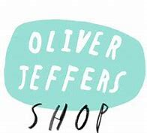 | Oliver will be reading one of his books every weekday at 6pm, and talking about some of the things that went into making it. If you can’t make it, Oliver will be posting the videos on his website. | English/Reading | EYFS/KS1/KS2
Story Time- Mac Barnett  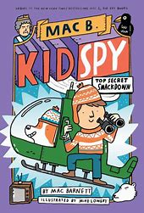 | Mac will be reading one of his books daily at 3pm | English/Reading | EYFS/KS1/KS2
Story Time- Peter Reynolds  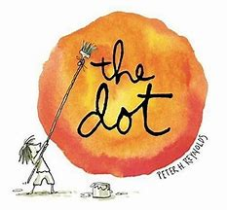 | Peter H Reynolds will be reading his books daily on his Facebook page at 4pm | English/Reading/Art | EYFS/KS1/KS2
Gad Book Club | Join actor Josh Gad (Frozen 2/Beauty and the Beast) will be reading popular books to children every night via Twitter in the #GadBookClub | English/Reading | EYFS/KS1/KS2
World eBook | World Book Online have just made their fabulous collection of over 3,000 ebooks and audiobooks available for free for children to access at home. They have books suitable for all ages. | English/Reading | EYFS/KS1/KS2
Home Safari-Cincinnati Zoo  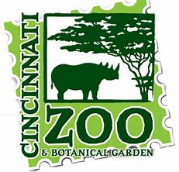 | While the Cincinnati Zoo is closed and kids are home from school, let us help make your children’s hiatus from school fun and educational. Join us for a Home Safari Facebook Live each weekday at 7pm where we will highlight one of our amazing animals and include an activity you can do from home. | Science | EYFS/KS1/KS2
Museum Virtual Tours | Google Arts & Culture teamed up with over 2500 museums and galleries around the world to bring anyone and everyone virtual tours and online exhibits of some of the most famous museums around the world.. | History/Science | EYFS/KS1/KS2
Lunch Doodles-Mo Willems  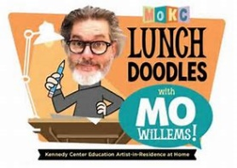 | Mo Willems invites YOU into his studio every day for his LUNCH DOODLE. Learners worldwide can draw, doodle and explore new ways of writing by visiting Mo’s studio virtually once a day for the next few weeks. Grab some paper and pencils, pens, or crayons and join Mo to explore ways of writing and making together.  New episodes will be posted each weekday at 5pm and then remain online to be streamed afterwards. | Art | KS1/KS2
Draw Every Day with JJK  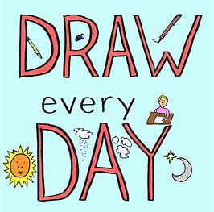 | Author of the Lunch Lady graphic novel series, Krosoczka will be hosting a daily drawing webcast on YouTube at 6pm. You can also find videos on his website. | Art | KS1/KS2
Drawing Tips-Nick Sharratt | Lots of videos with fun drawing activities | Art | EYFS/KS1/KS2
Sketchbook Art Skills  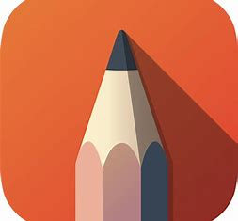 | Sheets with activities designed to support children to develop their art skills | Art | KS1/KS2
Make  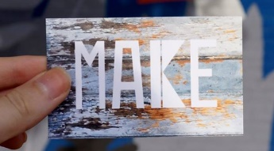 | Free art lessons on the Make Facebook page each weekday at 6pm. These will be family oriented for a range of ages and utilize supplies typically found in your home. | Art | KS1/KS2
Jump Start Jonny  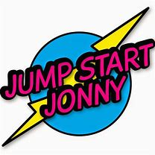 | Workouts and mindfulness activities for Jumpsters to do at home during school closures! | PE/Mindfulness | EYFS/KS1/KS2
Joe Wicks Kids Workouts  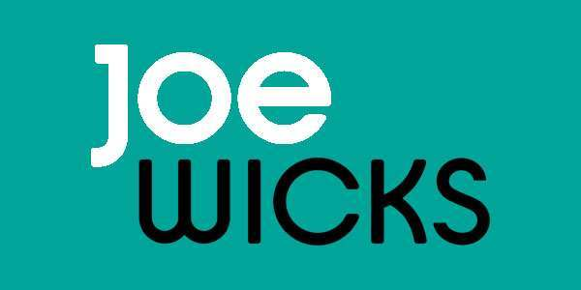 | Short Kid’s workouts to do at home | PE | EYFS/KS1/KS2
BBC Super Movers  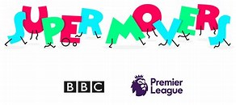 | Fun curriculum linked resources to get your kids moving while they learn | PE/Cross-curricular | EYFS/KS1/KS2
Go Noodle | Go Noodle have both an ‘At home’ and ‘For families’ option where you can access free movement and mindfulness videos | PE/Mindfulness | EYFS/KS1/KS2
Cosmic Kids Yoga  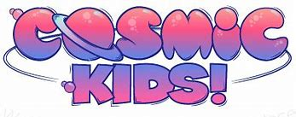 | Yoga, Mindfulness and Relaxation videos and story telling | PE/Mindfulness | EYFS/KS1.KS2
Go Kid Music Club | Learn some songs while learning sign language. A way of getting assembly/singing practice into your home routine! | Music/Sign | EYFS/KS1/KS2
White Rose Maths  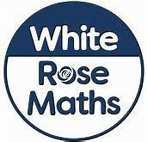 | The White Rose Maths Team have prepared a series of five brand new maths lessons for each year group from Years 1-8. Every lesson comes with a short video showing you clearly and simply how to help your child to complete the activity successfully. | Maths | KS1/KS2
Twinkl  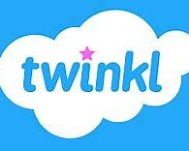 | Printable and Interactive Activities to support all areas of the curriculum  Enter the code: UKTWINKLHELPS or PARENTSTWINKLHELPS | Cross-curricular | EYFS/KS1/KS2/KS3
Classroom Secrets  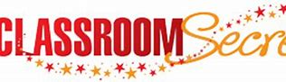 | Fun, interactive and practical home learning resources that are designed to be used by children. These include interactive games, video tutorials and downloadable home learning packs | Cross-curricular | EYFS/KS1/KS2

