READING DETECTIVES – Questions to ask of the text/of myself/of others after I have read the text
Summariser  What are the most important ideas or events?  What does the author want you to remember or learn from this?  What is the most important information in this part?  What was this part mostly about?  In your own words…. | Questioner  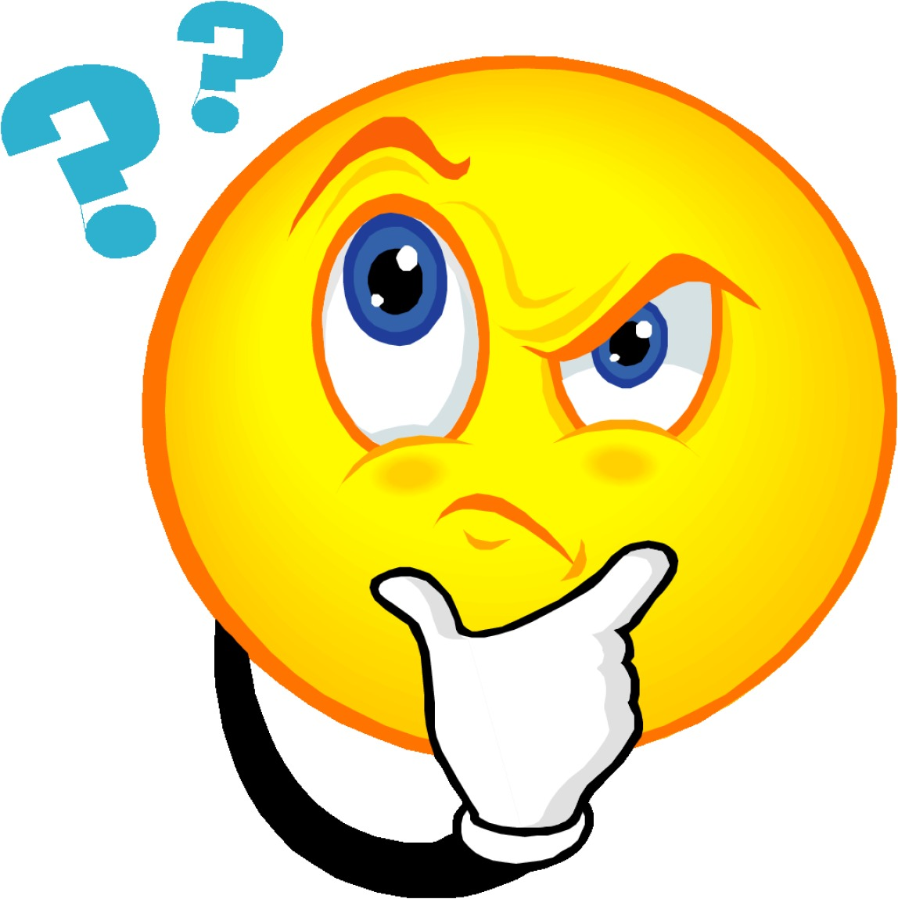  Is there anything I did not understand?  What else would I like to know?  What was I thinking about as I was reading?  Has anything like this ever happened to me?  Have I ever known anyone like this character?
Clarifier  Can I answer the questions?  What can I predict it means?  How can I check?  What strategies can I use to work this out?  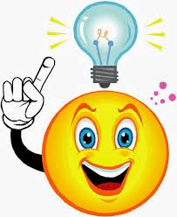 | Predictor  Based on what I’ve read and what I know..  What might happen next?  What clues helped me to think about what might happen next?  Is my prediction sensible?  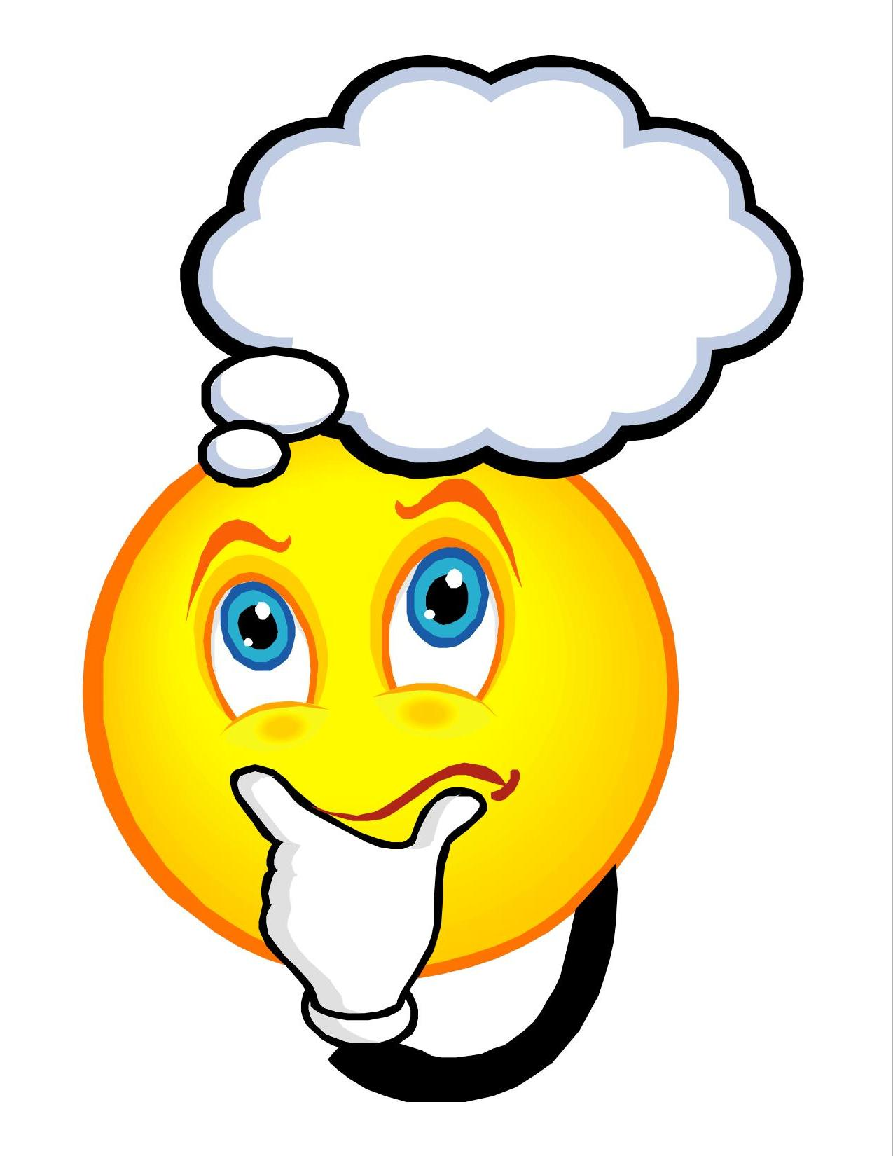

READING DETECTIVES – How to answer questions asked….
Summariser  Use the language of discussion  I think the most important points were…..  In this section we found out..  So the story moved on and we learnt that…  The most important information was ….  I predicted that we would find out….. but actually…..  My two key points from this section would be  You have only told me about the……is that all we have read about..  We learned first.. and then… | Questioner  Use the language of discussion  I’m not sure I understand why …  Why does it say?  Why does that…happen?  Is there anything you don’t understand?
Model useful reading behaviours
How to ask different sorts of questions

How to build on someone elses ideas and contributions and bringing other people into the discussion.

How to find relevant information to answer a question

The way to answer questions which require an inference or putting together information from different parts of the text

How to link suggested answers back to the text
Model useful reading behaviours
How to draw on the discussion in the clarify and question stages to use in the summary.

Finding the most important information and putting it into your own words.

Demonstrate how to decide what is the most important information.

Prompt readers to use these strategies  Scan for or highlight the most important words in the section.  Re-read the first and last sentences in each paragraph.  Use the subheadings to get an overview of the important information.  Identify 2 or 3 important sentences and try putting them into your own words. | Prompt readers to use these strategies  Think about what was read before. Were there any clues that could help you to answer the questions?  Just skim through that section again to see of there is an answer to that question  Is there anythign (from other things we have read, seen or discussed) which would help here?  Have we ever come across anything like this before?  Just re-read that sentence again. I think that might help to answer the question.  I think you are on the right track – but could you add (or could someone add the bit about)
Clarifier  Use the language of discussion  I’m not sure I understand…what does it mean?...  Can someone help me by explaining just what () is  As children become familiar with clarifying, they will start to sue these sorts of phrases to identify their own uncertainties. | Predictor  Use the language of discussion  I think we will find out more about…  I think (character) will … and..  We will learn how…  I think this bit is interesting. I think the next few paragraphs will tell us something more about it, like…….  From looking at the pictures and scanning the captions, I think..  I think that….introduced in the last section is important and ….  Well, building on what happened in the last chapter……
Model useful reading behaviours
How to take your ideas about a meaning of a word or phrase back to the sentence it was in – to check that it makes sense.

Model useful reading behaviours
Paint out what clues you’re using to make a prediction
How you need to think about (collate) what you know already

Prompt readers to use these strategies  Re- read the sentence. The context may make the meaning clearer.  Read on to the next sentence, the next sentence or the end of the paragraph. The word may be explained or its meaning may become clearer.  Link the unknown word to a word you already know (or part of a word) that it is like. Does that help with the meaning?  Check in the glossary if there is one.  Use a dictionary (at the end of the paragraph or section) to find the most appropriate meaning. | Prompt readers to use these strategies  Look closely at titles, sub headings, illustrations and headings- they give a quick way into the text  Scan the text for key words or repeated use of particular words- they are often useful clues  Skim read (letting your eye run across the text quickly) the first sentence of the next paragraph – you’ll often get a sense of what is coming from the lead in sentence or paragraph.  Pull together information from what you have read so far (collate) and think about it. Does that suggest what is likely to happen next?  Link what you know about this topic to what you have read. What does that suggest for what is coming? Good readers draw on what they know in order to understand something new that they are reading.  