St John Fisher Catholic Voluntary Academy
Headteacher: Mr A Gallagher

Tuesday 22nd September 2020

Dear Parents/Carers,

Due to the school being in lockdown because of Corona virus, your child missed their Year 1 Phonics Screening Check in June. Your child will now complete this statutory assessment in the second half of the Autumn term. We will let you know a date when one has been decided. This is a national test and all children in Year 2 this year will take part. The check entails children having to read a set of 40 words made up of real words and what we call ‘nonsense’ words. To be able to successfully pass the check the children need to be able to identify sounds in the words and blend them.

Your child should have been given a green and yellow phonics book last year. Please continue to use this with them to practise their set 2 and set 3 sounds. Accompanying this letter is a booklet with some nonsense words in for you to practise by getting your child to sound them out before reading them. We have been assessing the children since they have started back at school and so will send home some information on which sounds your child needs to learn or practise a bit more, enabling you to keep track of their progress.

On the Year 2 class page, we have uploaded a PowerPoint with some more information as well as some resources you can use and a list of websites.

If you have any further questions or would like to discuss this in more detail, please do not hesitate to contact us via email at year2@stjohnfisher-wigston.leics.sch.uk.

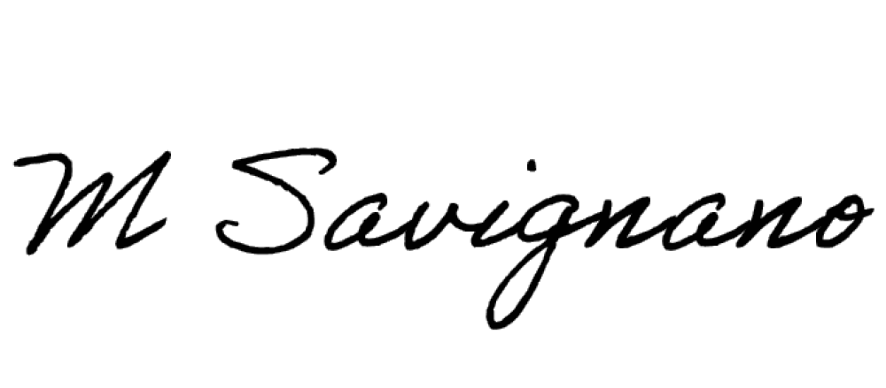
We appreciate the continued support. Many thanks,
A Stanley
Miss Savignano and Miss Stanley

St John Fisher Catholic Voluntary Academy, Shenley Road, Wigston,
Leicester, Leicestershire. LE18 3QL Tel: 0116 288 2203 Twitter: @StJohnFisherCVA
e-mail: office@stjohnfisher-wigston.leics.sch.uk Web Site: stjohnfisher-wigston.leics.sch.uk

