February 1st 2016

Lower KS2 Safer Internet Day Competition
Dear Parents and Carers,
E-safety is a key priority for all staff at St John Fisher Catholic Academy and has been a major focus in our computing lessons this year as well as embedding the importance of e-safety across the curriculum and throughout the school. Safer Internet Day 2016 is 2 weeks away, this raises awareness of why we need to keep safe online.
In the run up to this, we are running a competition for positive e-safety advice in the form of a ‘Be like Bill’ poster.
If your child is interested in taking part in this competition, please ask them to write their advice on a sheet of A5 paper and give to their teacher. Here are two examples.
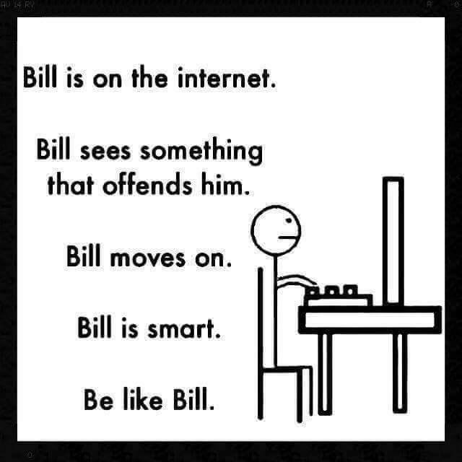
Bill is on his phone.
Bill reads someone write something mean.
Bill tells his Mum.
Bill is smart.
Be like Bill.

Closing date is 8th Feb 2016.
Winners announced on 9th Feb – Internet Safety Day.
We will also be running an assembly for children in the week of Safer Internet Day to reinforce the importance of safe internet use.

Thank you for your continued support on this ever important matter,

Mr Gallagher

Computing Subject Leader

