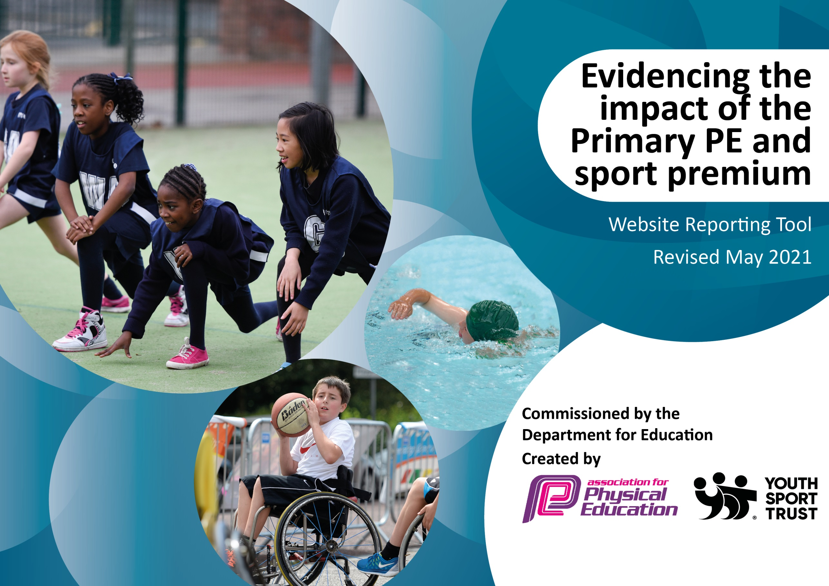

It is important that your grant is used effectively and based on school need. The Education Inspection Framework (Ofsted 2019 p64) makes clear there will be a focus on ‘whether leaders and those responsible for governors all understand their respective roles and perform these in a way that enhances the effectiveness of the school’.

Under the Quality of Education criteria (p41) inspectors consider the extent to which schools can articulate their curriculum (INTENT), construct their curriculum (IMPLEMENTATION) and demonstrate the outcomes which result (IMPACT).

To assist schools with common transferable language this template has been developed to utilise the same three headings which should make your plans easily transferable between working documents.

Schools must use the funding to make additional and sustainable improvements to the quality of Physical Education, School Sport and Physical Activity (PESSPA) they offer. This means that you should use the Primary PE and sport premium to:

- Develop or add to the PESSPA activities that your school already offer
- Build capacity and capability within the school to ensure that improvements made now will benefit pupils joining the school in future years
- The Primary PE and sport premium should not be used to fund capital spend projects; the school’s budget should fund these.
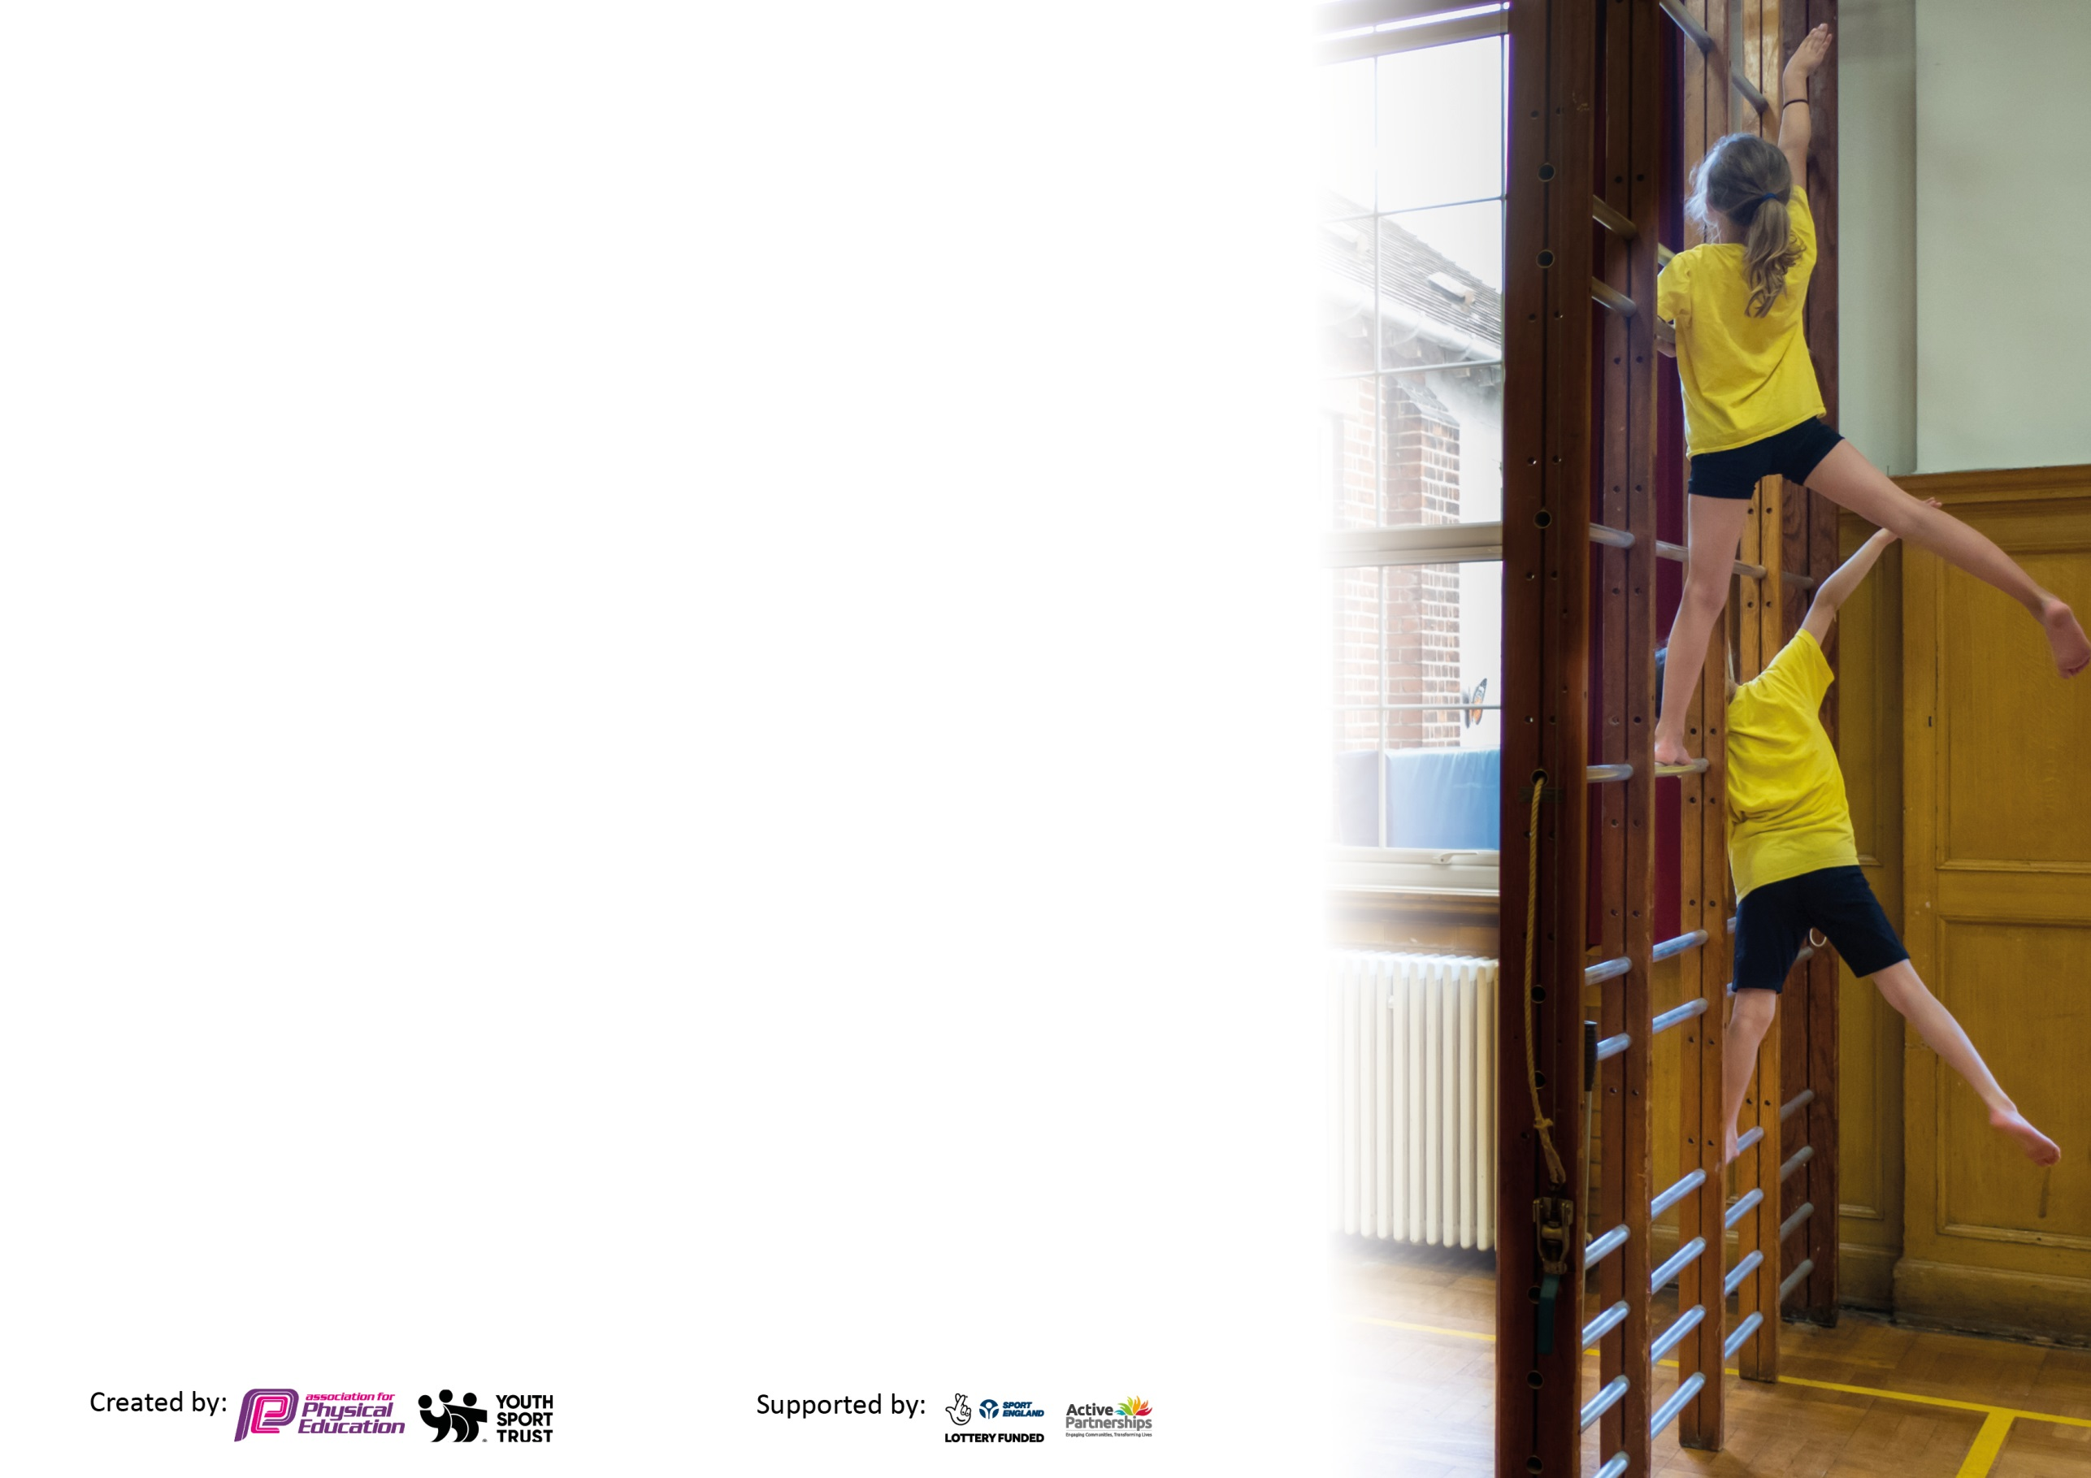
Please visit gov.uk for the revised DfE guidance including the 5 key indicators across which schools should demonstrate an improvement. This document will help you to review your provision and to report your spend. DfE encourages schools to use this template as an effective way of meeting the reporting requirements of the Primary PE and sport premium.

We recommend you start by reflecting on the impact of current provision and reviewing the previous spend.

Schools are required to publish details of how they spend this funding, including any under-spend from 2019/2020, as well as on the impact it has on pupils’ PE and sport participation and attainment by the end of the summer term or by 31st July 2021 at the latest.

We recommend regularly updating the table and publishing it on your website throughout the year. This evidences your ongoing self-evaluation of how you are using the funding to secure maximum, sustainable impact. Final copy must be posted on your website by the end of the academic year and no later than the 31st July 2021. To see an example of how to complete the table please click HERE.

Please note: Although there has been considerable disruption in 2020 it is important that you publish details on your website of how you spend the funding - this is a legal requirement.
Support for review and reflection - considering the 5 key indicators from DfE, what development needs are a priority for your setting and your pupils now and why? Use the space below to reflect on previous spend and key achievements and areas for development.

N.B. In this section you should refer to any adjustments you might have made due to Covid-19 and how these will influence further improvement.
Key achievements to date until July 2020: | Areas for further improvement and baseline evidence of need:
Swimming results – see published data  Sports offered virtually through website – LRS and SSPAN membership new initiatives for children to complete at home  Trim trail purchased end of the year – develop upper body strength, co-ordination, balance etc playtime equipment  Attendance of sports hall athletics – Goals  Football teams year 5  Cross Country events  Bikeability balance bikes EYFS and Year 6  Sports Leaders year 5 | Continued monitoring and evaluating through Learning walks and pupil voice to monitor implementation and impact of assessment within units of work  Pupils to know their strengths and areas for development – know what they need to improve, why and how  To see pupil progression horizontally across the year but vertically across  year groups and key stages matching up to NC expectations – ensure lessons mirror NC and sports coach – pupils making progress to meet end of key stage requirements  CPD for staff – areas identified through questionnaires  Adapting LTP ongoing to cater for lack of swimming and adhere to social distancing and non-contact games and activities  Courses and network meetings cancelled  Sports facilities closed and unable to travel to events

Did you carry forward an underspend from 2019-20 academic year into the current academic year? YES/NO * Delete as applicable
Total amount carried forward from 2019/2020 £2000
+ Total amount for this academic year 2020/2021 £17,724
= Total to be spent by 31st July 2021 £19,724

Meeting national curriculum requirements for swimming and water safety.

N.B Complete this section to your best ability. For example you might have practised safe self-rescue techniques on dry land which you can transfer to the pool when school swimming restarts.
Due to exceptional circumstances priority should be given to ensuring that pupils can perform safe self rescue even
if they do not fully meet the first two requirements of the NC programme of study.
What percentage of your current Year 6 cohort swim competently, confidently and proficiently over a distance of at least 25 metres?  N.B. Even though your pupils may swim in another year please report on their attainment on leaving primary school at the end of the summer term 2021.  Please see note above. | 85%  All % based on results of current year 6 pupils but data taken from year 4
What percentage of your current Year 6 cohort use a range of strokes effectively [for example, front crawl, backstroke and breaststroke]?  Please see note above. | 73%
What percentage of your current Year 6 cohort perform safe self-rescue in different water-based situations? | 73%
Schools can choose to use the Primary PE and sport premium to provide additional provision for swimming but this must be for activity over and above the national curriculum requirements. Have you used it in this way? | No

Action Plan and Budget Tracking
Capture your intended annual spend against the 5 key indicators. Clarify the success criteria and evidence of impact that you intend to measure to evaluate for pupils today and for the future.

Academic Year: 2020/21 | Total fund allocated: £17,724 | Date Updated: June 2021
Key indicator 1: The engagement of all pupils in regular physical activity – Chief Medical Officers guidelines recommend that primary school pupils undertake at least 30 minutes of physical activity a day in school |  |  |  | Percentage of total allocation:
 |  |  |  | 42%
Intent | Implementation |  | Impact
Your school focus should be clear what you want the pupils to know and be able to do and about  what they need to learn and to  consolidate through practice: | Make sure your actions to achieve are linked to your intentions: | Funding allocated: | Evidence of impact: what do pupils now know and what can they now do? What has changed?: | Sustainability and suggested next steps:
School Initiatives – KJ to find a new initiative to implement in school relaunch Daily Mile embed in school day – less time constraints on teachers than Daily Boost – Beat the Street  Liaise with companies for an all-weather track for daily exercise  Scooter and bike rack  . | KJ to enquire about Beat the Street Oadby and Wigston Council – to increase physical activity  Looking into an all-weather running track to encourage uptake of Daily Mile – outside exercise within bubbles to add 15 mins extra physical activity per day for all children alongside PE  Liaise with EdSpace – Premier Play and other companies to gain quotes – installation expected during May 2021  To encourage pupils to attend school on scooters improve physical activity – help with Beat the Street initiative | Free donated by the council  Quote agreed EdSpace  £8004.00  £250 | Reach inactive pupils, boost fitness levels for pupils who have been less active during lockdown. Encourage children to bike, scoot, walk to school and around the area.  Improve pupils’ fitness levels after home learning – allow pupils to access track all year round – re-launch daily mile and encourage participation through new initiative | Ongoing throughout the year - look into participation levels for 2021/22 – new initiatives ran by LRS or SSPAN  Looking to implement for Summer term
Key indicator 2: The profile of PESSPA being raised across the school as a tool for whole school improvement |  |  |  | Percentage of total allocation:
 |  |  |  | %
Intent | Implementation |  | Impact
Your school focus should be clear what you want the pupils to know and be able to do and about  what they need to learn and to  consolidate through practice: | Make sure your actions to achieve are linked to your intentions: | Funding allocated: | Evidence of impact: what do pupils now know and what can they now do? What has changed?: | Sustainability and suggested next steps:
KJ to bring in progression map across all year groups – teachers to be aware of learning objectives of each unit and age related expectations from previous learning  Develop assessment for learning alongside NC objectives  Through partnership meetings and research – shows pupils who know how to improve and what they need to improve will be more engaged | Progression map developed KJ Pentecost term for teachers to familiarise themselves for full use September 2021  Learning objectives part of the assessment for learning for each unit – so teachers can ensure LOB’s are met and tasks can be adapted as long as still covering the LOB’s - | CPD for KJ to be confirmed | Teachers are more aware of requirements and therefore adapt and differentiate tasks to suit individual needs within the class.  If tasks are adapted – pupil engagement and intrinsic motivation will improve – desire to achieve and take part.  Reason for this is that from pupil voice and through learning walks pupils stated that they are happy taking part in PE lessons and enjoy the activities, know that thye have progressed since previous years – but are not sure | Learning walks and pupil voice to monitor implementation and impact of assessment within units of work  Pupils to know their strengths and areas for development – know what they need to improve, why and how  To see pupil progression horizontally across the year but vertically across year groups and key stages matching up to NC expectations

Key indicator 3: Increased confidence, knowledge and skills of all staff in teaching PE and sport |  |  |  | Percentage of total allocation:
 |  |  |  | %
Intent | Implementation |  | Impact
Your school focus should be clear | Make sure your actions to | Funding | Evidence of impact: what do | Sustainability and suggested
what you want the pupils to know | achieve are linked to your | allocated: | pupils now know and what | next steps:
and be able to do and about | intentions: |  | can they now do? What has
what they need to learn and to |  |  | changed?:
consolidate through practice:
KJ to carry out staff questionnaires about areas for development – less confident and secure –  Share link of CPD month for staff to access in their own time and during staff meetings  TA’s and teachers to observe sports coach lessons and work with Leicester Tigers coach year 3 – to gain skills in specific areas | Staff meeting on Gymnastics as highlighted as one of the main areas required for staff CPD | Part of membership of SSPAN | Gymnastics not implemented this year due to Covid and pupils home learning during the Lent term | Next steps KJ to look into Gymnastics coaches to come in and work with staff and pupils on developing technique and how to enhance skills.  Look at Active PE gymnastics scheme of work to compliment NC requirements – interactive source – if for just 1 year, staff to feel more confident in the delivery and to collate resources
Key indicator 4: Broader experience of a range of sports and activities offered to all pupils |  |  |  | Percentage of total allocation:
 |  |  |  | 21%
Intent | Implementation |  | Impact
Your school focus should be clear | Make sure your actions to | Funding | Evidence of impact: what do | Sustainability and suggested
what you want the pupils to know | achieve are linked to your | allocated: | pupils now know and what | next steps:
and be able to do and about | intentions: |  | can they now do? What has
what they need to learn and to |  |  | changed?:
consolidate through practice:
Chris Gowan Sports Qualified Coach FA accredited coaching both Key stages and  Reception. Working on developing FUNdamentals of movement and implementing the following the Long Term plans across the Key Stages to ensure progress.  Climbatize – Outdoor activities for year 6 pupils – archery, survival skills, climbing wall, | Chris will work alongside the Teachers following a long term plan to ensure all areas of the curriculum are covered. Chris will focus on Reception and Key Stage One developing FUNdamentals in co-ordination, balance, speed, agility etc and then build these skills up through the key stages bringing in games play, rules, techniques etc. Liaise with PE Coordinator to feedback on ability etc. Works alongside other schools and attends LRS events.  Incorporate use of levels in PE feedback to pupils and PE Co-ordinator - learning walk and pupil voice KJ May 2021  MAB arranged for year 6 leavers instead of CRICH residential | Sports coaching  £3640 April  £450 approx | Pupils have access to after school football training (yr5 bubble only) at the moment, allowing them ongoing support and technique building. Pupils have benefited from a skilled coach with up to date knowledge and training in all aspects of PE. When asked the children who attended the football sessions said it boasted their confidence and knowledge of how to become a more skilled player. They would all like to play in competitive games against other schools. This additional support from a sports coach was evident in pupil success’ last year in school sports competitions particularly – Cross Country and Football. The hope is that attendance levels will increase across both activities. Staff who supervise the sessions, should become more confident in subject areas. | Ongoing  So far 12 children take part in football club – 4 girls and 8 boys, 3 children usually disengaged in PE lessons  Athletics club for year 3 and 4 introduced in Pentecost term

Key indicator 5: Increased participation in competitive sport |  |  |  | Percentage of total allocation:
 |  |  |  | 8%
Intent | Implementation |  | Impact
Your school focus should be clear | Make sure your actions to | Funding | Evidence of impact: what do | Sustainability and suggested
what you want the pupils to know | achieve are linked to your | allocated: | pupils now know and what | next steps:
and be able to do and about | intentions: |  | can they now do? What has
what they need to learn and to |  |  | changed?:
consolidate through practice:
Renewed membership to Leicester City Sports Partnership SSPAN for 1 year  Virtual and Digital games competitions  KS2 – 5K  KS2 – Digital games – Football Keep yuppies, accuracy  Sports hall athletics competiton all Key stages  Feb – skipping challenge  Boccia  Move it March  Basketball – Pentecost 1  Cross Country – June 2021  Sports Leaders – virtual delivery | Allows pupils to enter in a wide range of activities outside of their PE lessons and compete In challenges  Pupils to enter in intra competitions learning the skills and rules of games - All Virtual for Autumn term, Spring term  Use pentathlon event as a benchmark for each term to assess multi skills and progression across year groups.  Due to Covid lockdown focus will be on fitness and multi skills once pupils return.  Weekly fitness challenges set and promoted to pupils in school and at home to encourage physical activity and well being. Pupils to send in scores each week | All through SSPAN membership  £1368,00 | YR5 won the fastest combined team time across 44 teams in Leicestershire.  All classes took Part in KS2  First football challenge set as whole school challenge all took part – third challenge set as home learning – low uptake  Aim is that pupils who compete outside of school PE lessons n School Competitions last year developed an understanding in fair play, leadership, sportsmanship, teamwork, playing to the letter of the game, social, communication. Pupils who play against other children of the same age, can then make comparisons of their own ability and strive to improve. Gives opportunities for CPD courses at reduced rates. Pupils in Key Stage 2 achieving great results in Cross Country, Football Tournaments and came second in Sportshall Athletics. All going towards School Games Mark Award for last year. Awarded Gold 2019/20 still because of covid 19 . | Continuation attendance to network meetings for finding coaching to come into the school, resources, CPD, reduced training  KJ to upload data for competitions  Sending out resources and links for parents to well being activities to help during lockdown.

Signed off by
Head Teacher:
Date: | July 2021
Subject Leader: | K Jones
Date: | June 2021
Governor:
Date:

