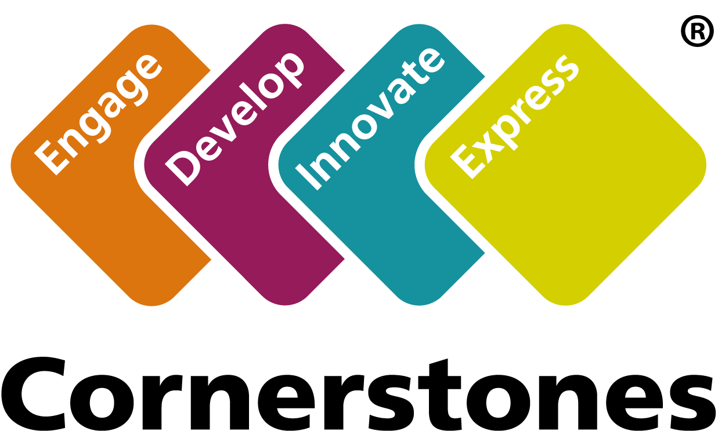

St John Fisher

Curriculum Policy
February 2020

Contents

Curriculum intent | 3
Aims | 3
Our approach | 3
Structure | 4
Engage | 4
Develop | 4
Innovate | 4
Express | 4
Memorable Experience | 5
Curriculum design for KS1 and KS2 | 5
Subject coverage | 5
English | 5
Mathematics | 5
Science | 5
Foundation subjects | 5
Religious education | 6
PHSE and citizenship | 6
ICT and computing | 6
Timetables | 6
Assessment of the curriculum | 6

Curriculum intent
Our curriculum is broad, balanced and meets the requirements of the national curriculum. It has a project-based, thematic approach and provides children with a range of rich and memorable learning experiences.

Aims
- Engage children through interesting topics and hands-on activities.
- Make meaningful links between subjects.
- Develop children’s skills, knowledge and understanding of a range of themes and concepts.
- Make effective connections to the real world.
- Help children to think creatively and solve problems.
- Develop children’s capacities to work independently and collaboratively.
- Enable children to make choices about their learning.
- Take account of children’s interests and fascinations.

Our approach:
- develops children to the best of their abilities
- helps children to find their passions and interests
- facilitates children’s acquisition of knowledge, skills and understanding
- helps children to develop intellectually, emotionally, socially, physically and morally
- assists children in becoming independent, responsible, useful, confident and considerate members of the community
- promotes a positive attitude towards learning, so children enjoy coming to school
- helps children to acquire a solid basis for lifelong learning
- creates and maintains an exciting and stimulating learning environment
- ensures that each child’s education has continuity and progression
- enables children to contribute positively within a culturally diverse society

Structure
Our curriculum is built on The Four Cornerstones of Learning – Engage, Develop, Innovate and Express. These are four distinct stages that actively promote children’s learning and thinking.
The Four Cornerstones of Learning link explicitly to pupils’ spiritual, moral, social and cultural (SMSC) development.
The focus for teaching and planning in each Cornerstone is as follows.

Engage
- hook learners in with a memorable experience
- set the scene and provide the context
- ask questions to provoke thought and interest
- use interesting starting points to spark children’s curiosity
Develop
- teach knowledge to provide depth of understanding
- demonstrate new skills and allow time for consolidation
- provide creative opportunities for making and doing
- deliver reading, writing and talk across the curriculum
Innovate
- provide imaginative scenarios for creative thinking
- enable and assess the application of previously learned skills
- encourage enterprise and independent thinking
- work in groups and independently to solve problems
Express
- encourage reflective talk by asking questions
- provide opportunities for shared evaluation
- celebrate success
- identify next steps for learning

Memorable Experience
Each Imaginative Learning Project (ILP) begins with a memorable experience that stimulates children’s curiosity and prepares them for a new theme. A memorable experience often involves an educational visit out of school or a visitor coming into school to share their expertise with the children.

Curriculum design for KS1 and KS2
Our curriculum design gives each year group the opportunity to cover a broad range of themes and subjects. Projects last either a half or full term depending on the amount of content and the children’s interests. In some cases, projects may be taught for a shorter period, for example during a science or art week.
Curriculum maps showing the coverage and structure for each year group can be found here.

Subject coverage
English
English is a core subject and is at the heart of our curriculum. Each project covers a range of reading and writing genres and, where appropriate, links to other areas of the curriculum.
A map of all the English genres covered across school can be seen here.
Spoken language is promoted throughout the curriculum and across all subjects.

Mathematics
Mathematics is also a core subject and is taught discretely through Maths No Problem.

Science
Science is fully covered throughout the curriculum. Some projects have a science focus, and others will have less of a scientific emphasis. Scientific enquiry is also delivered through the Cornerstones Love to Investigate scheme.

Foundation subjects
The foundation subjects – history, geography, design and technology, art and design, PE and music – are integrated into each project and provide enrichment across the curriculum.

Religious education
RE is a statutory part of the curriculum and as a Catholic school, we follow the local diocese scheme of work through Come and See.

PHSE and citizenship
PHSE and citizenship are important aspects of our curriculum and are taught both discretely and within the projects. This is done through weekly Circle time sessions (informed by the Statements to live by from the diocese) in each class and also discreet lessons covering topics such as friendship and changes in the body.

ICT and computing
The core skills of ICT are taught as a discrete programme across school. However, other elements of the computing curriculum are integrated into the curriculum as part of project work. These include e-safety, digital publication and presentation, research, data handling and the use of digital media.

Timetables
Each year group has a set of non-negotiable allocations for various aspects of the curriculum, including English, mathematics and PE. Teachers are free to arrange their afternoon timetable to make the most of cross-curricular opportunities and the needs of pupils. Sometimes subjects and activities might be ‘blocked’ or run over successive afternoons.

Assessment of the curriculum
At the beginning of each topic, each child will complete a Topic Quiz designed by the teachers based on what the children will be learning throughout that topic. They will then re-sit this quiz at the end of the topic, after all of the learning has taken place.
Children will also have the opportunity at the end of each topic to write an extended piece of writing, expressing what they have learnt and found out throughout the topic.

Creative learning with backbone
Office: 03333 20 8000
Email: support@cornerstoneseducation.co.uk
www.cornerstoneseducation.co.uk
Facebook: Cornerstones Education Ltd
Twitter: @Cornerstonesedu

Copyright © 2016 Cornerstones Education Limited

