[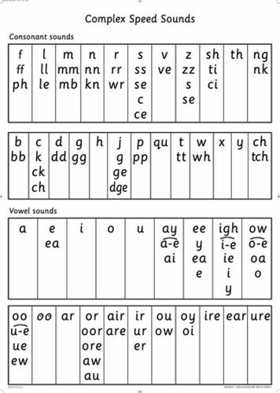](http://www.google.co.uk/url?sa=i&rct=j&q=&esrc=s&source=images&cd=&cad=rja&uact=8&ved=0ahUKEwiHhI7Ip8rKAhVL2RoKHWdADLsQjRwIBw&url=http%3A%2F%2Fwww.amazon.co.uk%2FRead-Write-Inc-Sounds-Poster%2Fdp%2F0198460473&psig=AFQjCNGI5RzN0aQ9fgvwcLH07CNZuqMKoQ&ust=1453994966511739)