There are many free websites with great resources that your child can access through the internet. If you google ‘maths games’ you will find thousands of sites. It is strongly advisable that children play games that are not too easy, but give them a challenge. Here are a few sites to get you started:

http://www.mad4maths.com/parents/
http://resources.woodlands-junior.kent.sch.uk/maths/
http://www.bbc.co.uk/schools/websites/4_11/site/numeracy.shtml
http://www.bbc.co.uk/skillswise
http://www.coolmath-games.com/
http://www.coreknowledge.org.uk/maths.php
http://www.ictgames.com/resources.html
http://www.counton.org/games/
http://www.topmarks.co.uk/maths-games/
There are many more sites that you can find using search engines, including Key Stage 2 SATs maths revision games and tasks!

Useful Apps

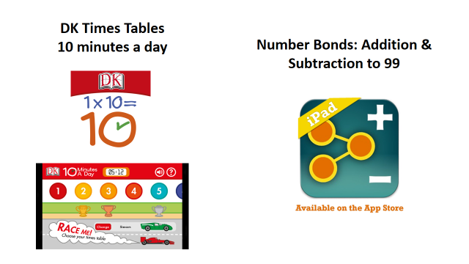

Depending on the topic your child is learning about in school you can do a google search for appropriate apps, or search the app store. Here are some sites to get you started:

- http://www.pcadvisor.co.uk/features/software/3380559/best-maths-apps-for-children/
- http://www.edutopia.org/blog/10-apps-for-math-fluency-monica-burns
- http://www.teacherswithapps.com/top-ten-classroom-math-apps-2/

